Literature review and project plan
  - Optimisation algorithms for robotic exploration of planetary bodies
mxyk17: Shin YOSHIZAWA

Scientific Background
Growing attention has been directed toward the long‑term sustainability of human activities beyond Earth. To enable a sustained human presence on other planetary bodies, essential life‑support resources—such as water, oxygen, and fuel—must be produced locally rather than transported from Earth. This concept, known as In‑Situ Resource Utilization (ISRU), has become one of the most critical challenges in lunar and Martian exploration.
In recent years, NASA and other space agencies have focused on the Permanently Shadowed Regions (PSRs) near the lunar poles. Because these regions have remained in darkness for billions of years, they maintain extremely low temperatures that prevent volatile substances from sublimating. As a result, PSRs are considered the most promising reservoirs of stable water ice on the Moon. Such ice can be converted into drinking water, oxygen (via electrolysis), and hydrogen (as rocket propellant), making it a vital resource for future lunar bases and human exploration missions ^{[1]}.

Planetary rover mobility problem
PSRs present some of the harshest environments in the Solar System: extreme cold (40–60 K), complete darkness, steep slopes, and poorly characterized regolith. These conditions make human access impossible. Moreover, orbital instruments cannot resolve near‑surface ice distribution or mechanical soil properties at the required spatial resolution, and static landers can only perform localized measurements.
Thus, mobile rovers are effectively the only viable means of directly investigating PSR surfaces, mapping ice concentration, and assessing regolith properties.
However, rovers face several critical challenges:
- they cannot be repaired once deployed,
- their size and mass are severely constrained,
- and they must traverse extremely hazardous terrain.
In particular, wheel sinkage, slip, and entrapment are difficult to avoid in unknown regolith conditions such as those found in PSRs.
Therefore, predicting rover mobility and optimizing wheel design during the engineering phase is essential for ensuring mission success.

Approaches to Improving Rover Mobility
Several research directions have been explored to enhance rover mobility. Representative approaches include:
- Metal wheel design for extreme environments ^{[2]}
These studies focus on wheel structures capable of withstanding extreme cold, vacuum, and radiation.
Limitation: While improving durability, they do not directly address sinkage or slip caused by wheel-soil interaction.
- Optimization of drivetrain and power transmission ^{[3]}
This line of research aims to improve torque distribution, actuator efficiency, and drivetrain reliability.
Limitation: It cannot resolve uncertainties arising from soil mechanics.
- Path planning using LRF and VFH ^{[4]}
Laser range-finding and Vector Field Histogram methods enable obstacle avoidance and safe navigation.
Limitation: These techniques do not influence traction, sinkage, or soil mechanical behaviour.
- Terramechanics-based wheel-soil interaction modelling and wheel design
Classical Terramechanics models (e.g., Bekker ^{[5]}, Wong-Reece ^{[6]}) are used to analyze wheel-soil interaction.
Limitation: Most studies rely on single-wheel experiments, empirical tuning, and simplified assumptions. They do not account for multi-wheel interactions, soil disturbance, or systematic exploration of the design space.
Therefore, there is a clear need for research that combines physics‑based simulation with meta‑heuristic optimization to systematically explore wheel design parameters. This study adopts such an approach.

Wheel-soil interaction
Rover mobility is fundamentally governed by how wheels interact with deformable planetary regolith. As a wheel traverses such terrain, it experiences vertical deformation, shear displacement, and slip, all of which determine traction, energy consumption, and the risk of entrapment.
In this study, wheel–soil interaction is characterized using three key performance indicators (KPIs) that directly influence rover mobility.
- Wheel sinkage
Wheel sinkage z represents the vertical penetration of the wheel into the soil. Greater sinkage increases motion resistance and raises the risk of immobilization.
Sinkage is commonly described by Bekker’s pressure-sinkage equation:
$$\begin{aligned}p=\left(\frac{k_{c}}{b}+k_{∅}\right)z^{n}\#\left(1\right)\end{aligned}$$where p is the pressure, b is the smaller dimension of the contact path/width of the rectangular contact area, z is the sinkage and n, k_{c}, and k_{Φ} are the pressure-sinkage parameters.
This relationship shows that wheel geometry and soil properties jointly determine sinkage, which directly affects drag and mobility. ^{[7]}
- Drawbar pull
In this study, Drawbar pull F_{DP} is defined as the net usable tractive force derived from the driving torque, after accounting for soil resistance.
Under steady-state (constant-velocity) motion, the moment balance around the wheel centre can be written as:
$$\begin{aligned}T=F_{DP}r_{s}+F_{N}\#\left(2\right)\end{aligned}$$where T is driving torque generated by the wheel motor and reduction gears, r_{s} is equivalent shearing radius of the wheel, F_{N} is normal force exerted on the wheel by soil and e is moment arm of the soil resistance.
This formulation makes it explicit that Drawbar pull depends not only on the applied torque, but also on normal load, soil resistance, and wheel geometry. ^{[8]}
- Slip ratio
Slip ratio s quantifies the mismatch between commended and actual wheel motion:
$$\begin{aligned}s=\frac{r_{s}-v}{r_{s}ω}\#\left(3\right)\end{aligned}$$where ω is angular velocity of the wheel and v is linear velocity of the wheel. ^{[8]}

Limitations of classical Terramechanics models
The analytical relations introduced in Section 1.3 - such as Bekker’s pressure–sinkage equation and the shear stress formulation - are based on classical Terramechanics models. Terramechanics provides analytical and semi‑empirical tools for predicting wheel–soil interaction and has long served as the foundation of rover mobility analysis.
However, these models were originally developed for military and agricultural vehicles operating on Earth, and rely heavily on single‑wheel experiments ^{[9]}. As a result, they incorporate several simplifying assumptions:
- homogeneous and isotropic soil,
- steady‑state motion,
- a single, well‑defined contact patch,
- negligible wheel–wheel interaction,
- no soil disturbance effects from preceding wheels.
These assumptions limit their applicability to multi‑wheel planetary rovers, where front wheels disturb the soil for subsequent wheels, and suspension dynamics redistribute loads across the vehicle. Recent multibody dynamics studies - such as analyses of the Yutu lunar rover - demonstrate that multi‑wheel behaviour cannot be captured by simple superposition of single‑wheel Terramechanics models.
Thus, while Terramechanics remains essential for understanding fundamental wheel–soil mechanics, it is insufficient for modern rover design, motivating the need for enhanced modelling frameworks and optimisation‑based approaches.

Optimisation approaches
Most prior research focuses on analysing wheel performance rather than optimizing wheel geometry. Studies using Terramechanics models have proposed empirical design criteria for estimating wheel dimensions, but these approaches do not explore the full design space or account for multi-wheel interactions.
High-fidelity numerical methods such as DEM (Discrete Element method) or SPH (Smoothed Particle Hydrodynamics) can simulate complex soil behaviour but are computationally expensive, making them unsuitable for large-scale design optimization.
Therefore, a promising approach is to combine:
- Physics-based Terramechanics models
- Meta-heuristic optimization algorithms
This hybrid strategy enables efficient exploration of wheel design parameters such as wheel radius, wheel width, grouser height, grouser spacing, number of grousers, and wheel geometry parameter.
By integrating simulation and optimization, it becomes possible to identify wheel designs that maxmise traction efficiency while minimizing sinkage and energy consumption.

Anticipated outcomes
The project outcomes are divided into basic, intermediate, and advanced goals, each with different levels of difficulty and risk.

Basic goal
To implement a Terramechanics‑based wheel–soil interaction model, primarily using Bekker’s formulation, and to construct a single‑wheel mobility simulation.
The model must be capable of computing the three KPIs defined in Section 1.3: wheel sinkage, drawbar pull, and slip ratio.

Intermediate goal
To explore wheel design parameters using meta‑heuristic optimisation within a fast Terramechanics‑based simulation environment.

Advanced goal
To evaluate the effects of multi‑wheel interaction, including wheel interference, load redistribution, and soil disturbance.
Based on the limitations discussed in Section 1.4, the aim is to verify mobility behaviours that cannot be explained by simple superposition of single‑wheel models.

Research question
This study addresses the following two core questions:
- What wheel design parameters maximise traction efficiency and minimise sinkage for planetary rovers on deformable soil?
- How can meta-heuristic optimisation be used to determine the optimal wheel geometry for planetary exploration rovers operating on deformable regolith terrain?

Methodology
The project plan is structured into five main development stages, followed by the writing phase, for a total of six stages.
Milestones are placed between stages to minimise delays and prevent rework by ensuring smooth transitions across the workflow.

Requirements Definition
This stage focuses on understanding prior research and defining the problem addressed in this study.
The key tasks include:
- identifying the problem formulation relevant to planetary rover mobility,
- defining the evaluation criteria and KPIs used in this research,
- clarifying the success conditions based on Sections 1.3 and 1.5.
Terramechanics assumptions and limitations (Section 1.4) are also reviewed to establish the necessary model requirements.

System Design
In this stage, the core knowledge required for the project - wheel–soil interaction (Terramechanics) and optimization - is consolidated.
A simulation framework is designed, and an appropriate simulator is selected based on computational efficiency and extensibility.

Detailed Design
Based on the system framework, the detailed design stage specifies:
- the parameters to be implemented,
- the Initial Test Plan,
This stage ensures full consistency between the KPI definitions in Section 1.3 and the success criteria in Section 5.

Implementation
Implementation is carried out according to the Initial Test Plan.
Two main components are developed: wheel-soil interaction model and optimization model.

Simulation Experiments
Simulation experiments are conducted using the implemented models.
The results are analysed using the KPIs to assess optimisation performance and to examine the limitations of classical Terramechanics models discussed in Section 1.4.
Figure 1 presents the Gantt chart for this project, showing the overall timeline and the sequence of major tasks. Figure 2 summarises the task list used as input for the Gantt chart, including the start and end dates of each task. In this scheduling tool, identical start and end dates indicate a milestone.
Figure 1 Gantt chart
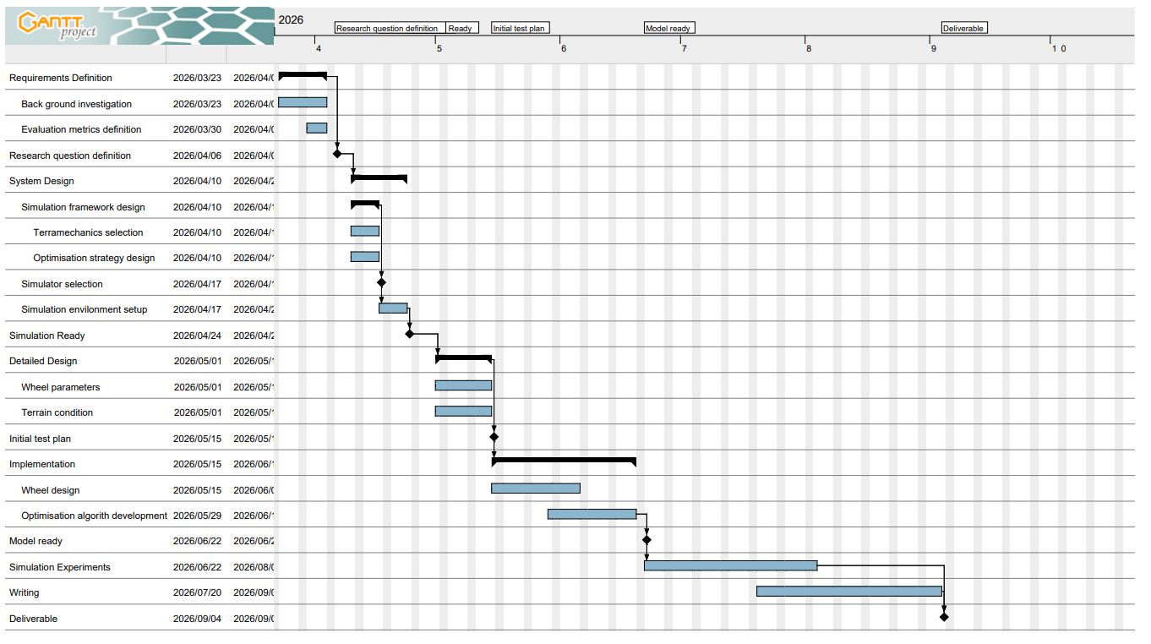

Figure 2 Task list
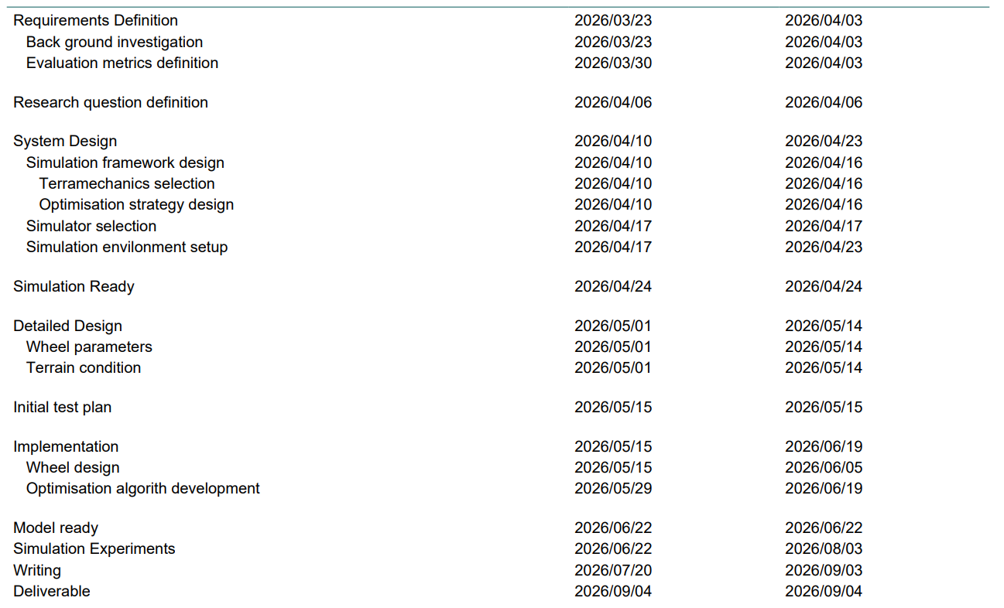

Success demonstration
To demonstrate that the proposed approach is correct, robust, and effective, the following tests will be conducted.

KPI
The three KPIs defined in Section 1.3 are mandatory, with additional metrics considered as needed:
- Drawbar pull
- Wheel sinkage
- Slip ratio
- Traction efficiency
- Energy consumption

Test conditions
- Different wheel shapes
- Different soil parameters
- Different gravity conditions
- Single-wheel vs multi-wheel comparison

Criteria
A design is considered successful if:
- Optimised wheel design shows higher traction efficiency and lower sinkage than baseline designs.
- Sinkage is reduced under equivalent load condition.
- Slip ration decreases, indicating improved energy utilization.
- Simulation results match published Terramechanics data for validation.
- Performance improvements generalize across multiple soil types.

Reference
- [1] W. Reid and C. Webster, “Mobility System Evaluation for Traversing Permanently Shadowed Regions on the Moon,” NASA Technical Report, FY21 R&TD Innovative Spontaneous Concepts, Clearance No. R21217, 2021.
- [2] W. Song, M. Zou, Z. Dang, B. Chen, T. Zhou, and B. Su, “Modelling of flexible metal wheels for planetary rover on deformable terrain,” Thin-Walled Structures, vol. 141, pp. 97–110, 2019.
- [3] A. Patankar, R. Kulkarni, S. Kothawade, and S. Ingale, “Design and development of a transmission system for an all terrain vehicle,” International Journal of Mechanical Engineering and Technology (IJMET), vol. 7, no. 3, pp. 351–359, May–June 2016, Article ID: IJMET_07_03_032.
- [4] Y. Tanaka, Y. Ji, A. Yamashita, and H. Asama, “Fuzzy based traversability analysis for a mobile robot on rough terrain,” Technical Report, University of Tokyo.
- [5] Laughery, S., Gerhart, G., and Goetz, R. (1990). Bekker’s Terramechanics model for off-road vehicle research. U.S. Army TARDEC Technical Report, Warren, MI, USA.
- [6] K. Skonieczny, S. J. Moreland, and D. S. Wettergreen, “A grouser spacing equation for determining appropriate geometry of planetary rover wheels,” Technical Report, NASA.
- [7] G. Tsitouridis, “Terramechanics and soil–wheel interactions for road vehicle applications,” Ph.D. dissertation, Loughborough University, 2019.
- [8] Bauer, R., Leung, W., & Barfoot, T. (2005). Experimental and simulation results of wheel–soil interaction for planetary rovers. In Proceedings of the IEEE/RSJ International Conference on Intelligent Robots and Systems (IROS), Edmonton, Canada.
- [9] Ding, L., Gao, H., Deng, Z., Nagatani, K., and Yoshida, K. (2011). Experimental study and analysis on driving wheels’ performance for planetary exploration rovers moving in deformable soil. Journal of Terramechanics, 48, 27–45.

